BEST STANDARD WEEKLY REPORT ON 09/06/2014

Software Name : BS ENTERPRISE SOLUTION

Discussed Improvements

1. In Quotation Full Invoice the no of PO Instrument Quantity is not equal and can be Unequal with the quotation. Purchase Order always contains the instruments of more than one quotation. But the current system is not updated in this format. As it’s changing the theme of the process flow in the purchase order. We need to implement it in a way.
2. Dashboard Calendar Improvement in the Maintaining of Month wise Job Data’s which is described below.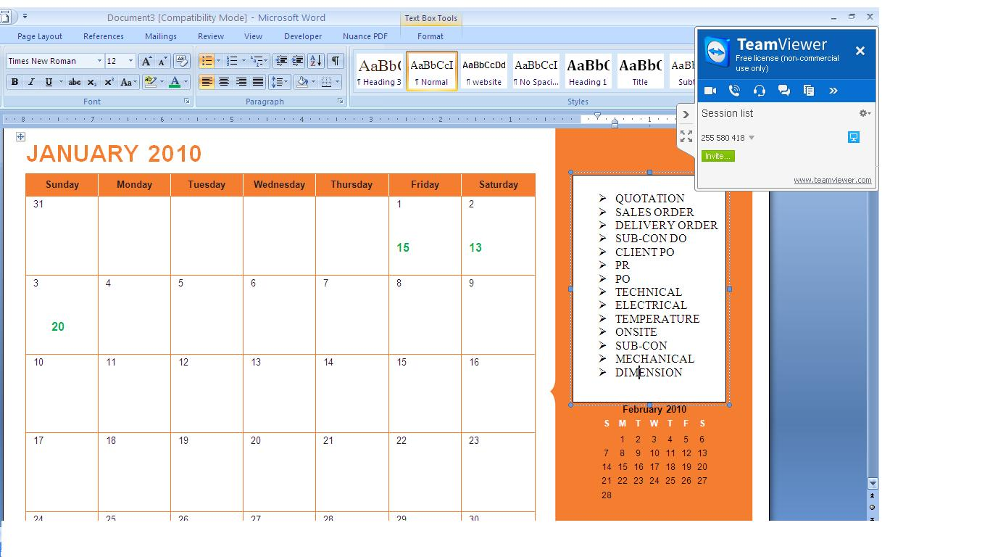
3. Dashboard Message Display in Tab wise Job management is proposed as new improvement. Since the old one causes inability of tracking data in a simpler way for admin. If a Large set of Data is Show, the new improvement helps in a way to split things up.
4. Approval Too improvised based on the above (3) point.
5. Advance search in Instrument Pricing is mentioned & it will be updated.
6. Customer Tags Concept is improvised slightly to facilitate data accuracy in the Customer Entry (It affects process flow in the whole system due to additional companies using tagging system). But its almost implemented and will be updated.